GROWING

//Date: 24-01-2019

//Authors: Jolt Wiersma, Michelle A. Menkiti, Arthur Masure

//Adapted from work by: Shervin Azadi, Dr.ir. Pirouz Nourian, Hans Hoogenboom

//Purpose: To grow the initial seed voxels based on data given to it by a .csv file and to give each function a squareness

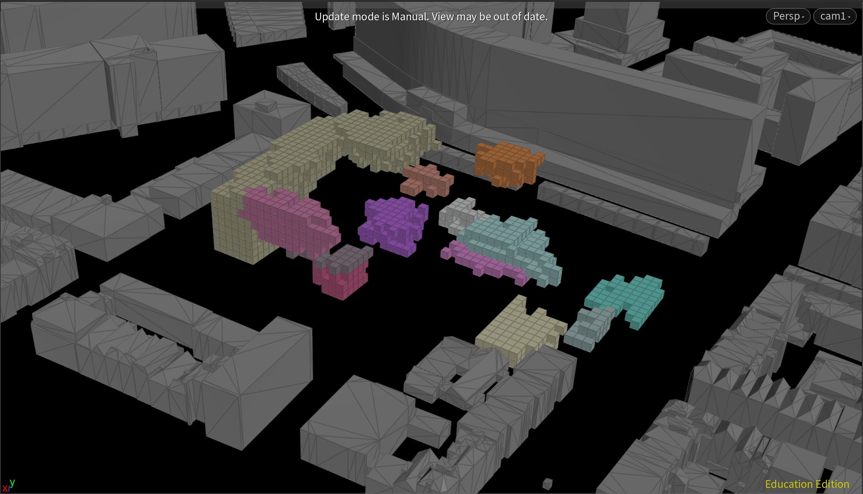

GROWTH OF FUNCTIONS IMPLEMENTING GROWTH HEIGHT, AREA, AND SQUARENESS

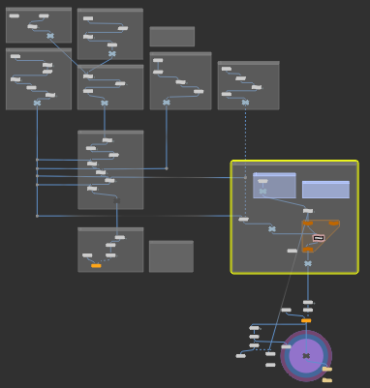

//user input

float squareness_factor = chf("squareness_factor");

//GET NUMBER OF PARENTS/AGENTS (FUNCTIONS)

int num_agents = npoints(1);

//FOR EVERY PARENT SEED IN THE ENVELOPE

for (int Agent = 0; Agent < num_agents; Agent++)

{

//prepare wp name

string wp_name = "wp" + itoa(Agent);

//prepare a list for y-values

int y_values[];

//get number of children allocated to that parent (agent)

int num_children = findattribvalcount(0, "point", "parent", Agent);

//get desired area for that parent (agent)

int desired_area = point(1, "area", Agent);

//get desired number of floors to grow on for that parent (agent)

int number_of_floors = point(1,"GrowthHeight",Agent);

//IF THE DESIRED AREA (UNITS: NUMBER OF VOXELS) IS GREATER THAN THE NUMBER OF CHILDREN

if (desired_area > num_children)

{

//CREATE A LIST OF BOUNDARY VOXEL ID POINTS

int agent_boundary_id[];

//CREATE A LIST OF BOUNDARY VOXEL WEIGHTED PRODUCTS

float agent_boundary_wp[];

//get the y-value of the parent (as float and int)

int seed_parent_id = findattribval(0,"point","Seed",Agent, 0);

vector pos = point(0,"P",seed_parent_id);

float y_value = pos.y;

int seed_IPY = point(0,"IPY",seed_parent_id);

y_values = point(0,"Y_Values",seed_parent_id);

//add the y-value of the parent to the list of y-values

append(y_values,seed_IPY);

//FOR EVERY CHILD OF THE PARENT

for (int Child = 0; Child < num_children; Child++)

{

//GET THE POINT ID OF THE CHILD

int voxel_id = findattribval(0, "point", "parent", Agent, Child);

//CREATE A LIST OF THE POINT ID'S OF THE NEIGHBOURS OF THE CHILD

int voxel_neighbours[] = neighbours(0, voxel_id);

//remove neighbours that are too far away

foreach (int Neigh; voxel_neighbours)

{

vector pos_1 = point(0,"P",Neigh);

float distance = distance(pos_1,pos);

if (distance > 3)

{

removevalue(voxel_neighbours,Neigh);

}

}

//FOR EVERY NEIGHBOUR OF THE CHILD

foreach (int Neigh; voxel_neighbours)

{

//IF THE NEIGHBOUR IS NOT OCCUPIED

if (inpointgroup(0, "occupied", Neigh) == 0)

{

//get the y-value of the neighbour (as float and int)

vector bound_pos = point(0,"P",Neigh);

float y_value_boundary = bound_pos[1];

int bound_IPY = point(0,"IPY",Neigh);

//get the weighted product of that neighbour

float neigh_wp = point(0,wp_name, Neigh);

setpointattrib(0,wp_name,Neigh,neigh_wp*squareness_factor,"set");

//IF AGENT DESIRES RANDOM GROWTH (CSV)

if (number_of_floors == 0) // csv = 0

{

//ADD THE NEIGHBOUR'S POINT ID TO THE LIST OF BOUNDARY VOXEL POINT ID'S

append(agent_boundary_id, Neigh);

//ADD THE NEIGHBOUR'S WEIGHTED PRODUCT TO THE LIST OF BOUNDARY VOXEL WEIGHTED PRODUCTS

append(agent_boundary_wp, neigh_wp);

}

//IF AGENT DESIRES GROWTH ON 1 VOXEL LAYER (CSV)

if (abs(y_value_boundary - y_value) < 0.001 && number_of_floors == 1) //y-values are relatively equal and csv = 1

{

//ADD THE NEIGHBOUR'S POINT ID TO THE LIST OF BOUNDARY VOXEL POINT ID'S

append(agent_boundary_id, Neigh);

//ADD THE NEIGHBOUR'S WEIGHTED PRODUCT TO THE LIST OF BOUNDARY VOXEL WEIGHTED PRODUCTS

append(agent_boundary_wp, neigh_wp);

}

//IF AGENT DESIRES GROWTH ON MORE THAN 1 OR RANDOM VOXEL LAYERS (CSV)

if (number_of_floors > 1); // csv > 1

//IF THE NEIGHBOUR'S Y-VALUE IS IN THE LIST OF PARENT Y-VALUES

if (find(y_values, bound_IPY) > -1)

{

//ADD THE NEIGHBOUR'S POINT ID TO THE LIST OF BOUNDARY VOXEL POINT ID'S

append(agent_boundary_id, Neigh);

//ADD THE NEIGHBOUR'S WEIGHTED PRODUCT TO THE LIST OF BOUNDARY VOXEL WEIGHTED PRODUCTS

append(agent_boundary_wp, neigh_wp);

}

//OTHERWISE, IF THE LIST OF PARENT Y-VALUES IS 'FULL' (the length of the list is less than the desired number of floors)

else if (len(y_values) < number_of_floors)

{

//ADD THE NEIGHBOUR'S POINT ID TO THE LIST OF BOUNDARY VOXEL POINT ID'S

append(agent_boundary_id, Neigh);

//ADD THE NEIGHBOUR'S WEIGHTED PRODUCT TO THE LIST OF BOUNDARY VOXEL WEIGHTED PRODUCTS

append(agent_boundary_wp, neigh_wp);

//ADD THE NEIGHBOUR'S Y-VALUE TO THE LIST OF PARENT Y-VALUES

append(y_values,bound_IPY);

}

}

}

}

//Set the maximum as a new child for the parent

//SORT THE LIST OF BOUNDARY VOXEL WEIGHTED PRODUCTS FROM MAXIMUM TO MINIMUM

int sorted_indecies[] = reverse(argsort(agent_boundary_wp));

//SORT THE LIST OF BOUNDARY VOXEL POINT ID'S FROM MAXIMUM TO MINIMUM

int sorted_boundary_id[] = reorder(agent_boundary_id, sorted_indecies);

//SET THE CHILD WITH THE MAXIMUM WEIGHTED PRODUCT (FIRST INDEX) AS A PARENT AND AS OCCUPIED

setpointattrib(0, "parent", sorted_boundary_id[0], Agent, "set");

setpointgroup(0, "occupied", sorted_boundary_id[0], 1, "set");

}

//attribute to check amount and value of y-values in list of y-values for that agent

int seed_parent_id = findattribval(0,"point","Seed",Agent, 0);

setpointattrib(0,"Y_Values",seed_parent_id,y_values,"set");

}